## Optimalizácia konvergovaných sietí

# Cvičenie č.8 – Policing a shaping

### Peter Hadač & Pavol Tuka

# Policing

**Generované dáta (D-ITG):**

* Tok: kolísavý okolo: a.) aj b.) 84 kb/s UDP, c.) 112kbps (kolísavý chceme preto, aby sme videli obmedzovanie a tvarovanie/vyhladzovanie prevádzky)
* Intenzita: 35 pak/s - náhodné časy príchodov s expon. rozdelením, pričom priemerne bude chodiť 35 pak/s
* Veľkosť paketov náhodná - spravte pre každý scenár (viď nižšie) tieto 3 varianty:
* a.) s rovnomerným rozdelením = uniform od 100 do 500 B
* b.) s exponenciálnym rozdelením  so strednou veľkosťou paketu 300 B
* c.) s exp. rozdelením so strednou dĺžkou 400 B
* Policing: 84 kb/s

**1.Scenár - Single rate two color (jednoduchý token bucket)**

**Obmedzovať** prevádzku (policing) možno tak pre triedu class-default ako aj pre ktorúkoľvek špecifickú triedu (my budeme robiť tú druhú možnosť). Obmedzovať budeme čo najbližšie k zdroju, takže na vstupnom porte nášho smerovača z danej LAN:

* ***Vytvorte triedu „ZAKAZNIK“ (class-map), do ktorej spadne všetka generovaná UDP prevádzka D-ITG generátorom (najjednoduchšie je použiť vhodný ACL)***

!

class-map match-all ZAKAZNIK

match access-group 101

!

access-list 101 permit udp any any

!

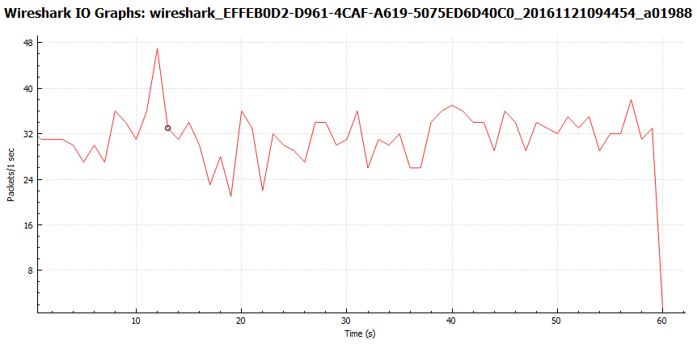

Flow number: 1

From 10.0.1.2:56556

To 10.0.2.2:9001

----------------------------------------------------------

Total time = 59.933000 s

Total packets = 1883

Minimum delay = 14.364000 s

Maximum delay = 14.739000 s

Average delay = 14.530552 s

Average jitter = 0.012612 s

Delay standard deviation = 0.070133 s

Bytes received = 547861

Average bitrate = 73.129795 Kbit/s

Average packet rate = 31.418417 pkt/s

Packets dropped = 279 (12.90 %)

Average loss-burst size = 1.367647 pkt

* ***Vytvorte politiku „POLICING1_DROP“ (policy-map) pre obmedzovanie (policing) prevádzky nasledovne:***

1. ***Všetky pakety triedy ZAKAZNIK nech označkuje DSCP hodnotou 2***
2. ***Pakety nad dovolený rámec 84 kbps (CIR) nech zahadzuje, ostatné nech prepúšťa.***

policy-map POLICING1_DROP

class ZAKAZNIK

set dscp 2

police cir 84000

conform-action transmit

exceed-action drop

!

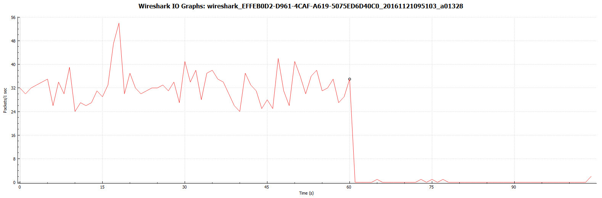

__________________________________________________________

**************** TOTAL RESULTS ******************

__________________________________________________________

Number of flows = 1

Total time = 60.908000 s

Total packets = 1940

Minimum delay = -49.619000 s

Maximum delay = -48.605000 s

Average delay = -49.207541 s

Average jitter = 0.016544 s

Delay standard deviation = 0.258432 s

Bytes received = 506190

Average bitrate = 66.485848 Kbit/s

Average packet rate = 31.851317 pkt/s

Packets dropped = 175 (8.27 %)

Average loss-burst size = 1.215278 pkt

Error lines = 0

* ***Politiku aplikujte na f0/0 vo vstupnom smere.***

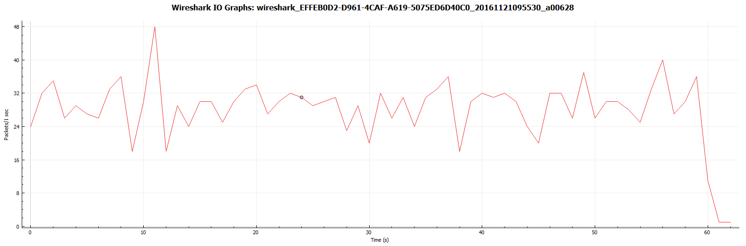

__________________________________________________________

**************** TOTAL RESULTS ******************

__________________________________________________________

Number of flows = 1

Total time = 60.437000 s

Total packets = 1750

Minimum delay = -39.694000 s

Maximum delay = -39.181000 s

Average delay = -39.414976 s

Average jitter = 0.018588 s

Delay standard deviation = 0.104725 s

Bytes received = 535378

Average bitrate = 70.867581 Kbit/s

Average packet rate = 28.955772 pkt/s

Packets dropped = 354 (16.83 %)

Average loss-burst size = 1.351145 pkt

Error lines = 0

----------------------------------------------------------

* Využite výpis *sh policy-map int f0/0* a zistite:

|  |  |
| --- | --- |
| ***CIR*** | *84000 b* |
| ***BC*** | *2625 B* |
| ***Tc*** | *0,25s (2625*8/84000)* |
| ***1/Tc*** | * 1. *tokeny / s sa doplnia* |

**Teraz** pakety presahujúce limit nezahadzujte, ale označkujte ich DSCP značkou af12, aby sme ich videli v IO graphs vo Wiresharku:

* Vytvorte politiku „POLICING1_FARBI“

1. Všetko bude ako predošlé, akurát *exceed-action* sa zmení z *drop* na*set-dscp-transmit af12*
2. Najprv deaktivujte predošlú politiku, následne aplikujte novú na to isté rozhranie.

policy-map POLICING1_FARBI

class ZAKAZNIK

police cir 8000

exceed-action set-dscp-transmit af12

červená - všetko

zelená - dscp = AF12

#### Tok1

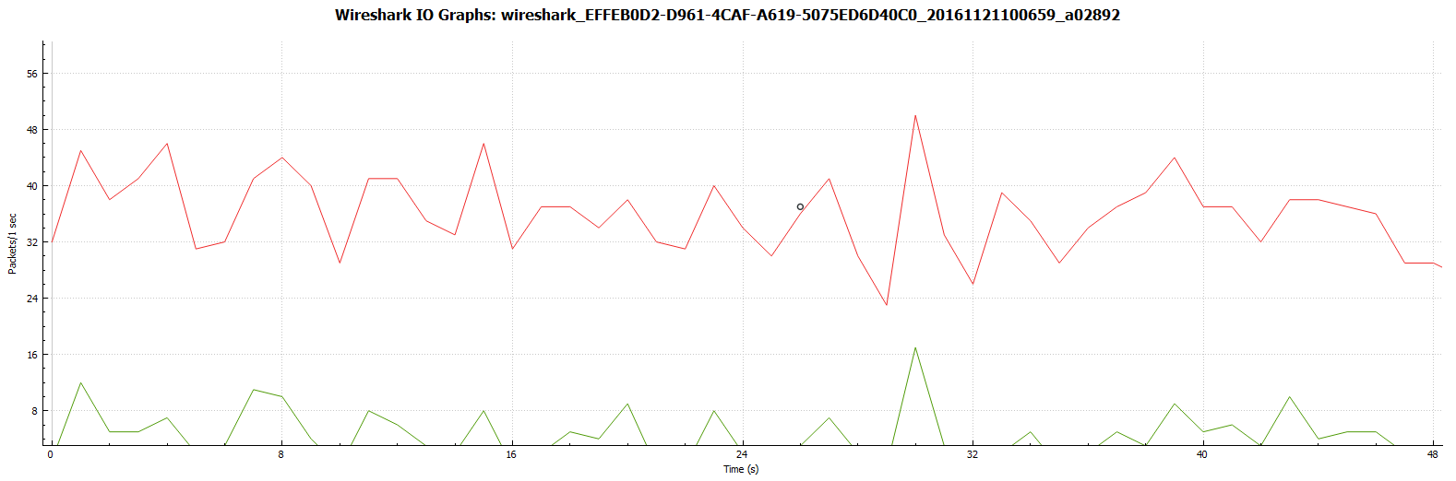

__________________________________________________________

**************** TOTAL RESULTS ******************

__________________________________________________________

Number of flows = 1

Total time = 60.130000 s

Total packets = 2185

Minimum delay = -36.756000 s

Maximum delay = -36.320000 s

Average delay = -36.570072 s

Average jitter = 0.014835 s

Delay standard deviation = 0.104015 s

Bytes received = 646416

Average bitrate = 86.002461 Kbit/s

Average packet rate = 36.337934 pkt/s

Packets dropped = 0 (0.00 %)

Average loss-burst size = 0 pkt

Error lines = 0

----------------------------------------------------------

#### Tok 2

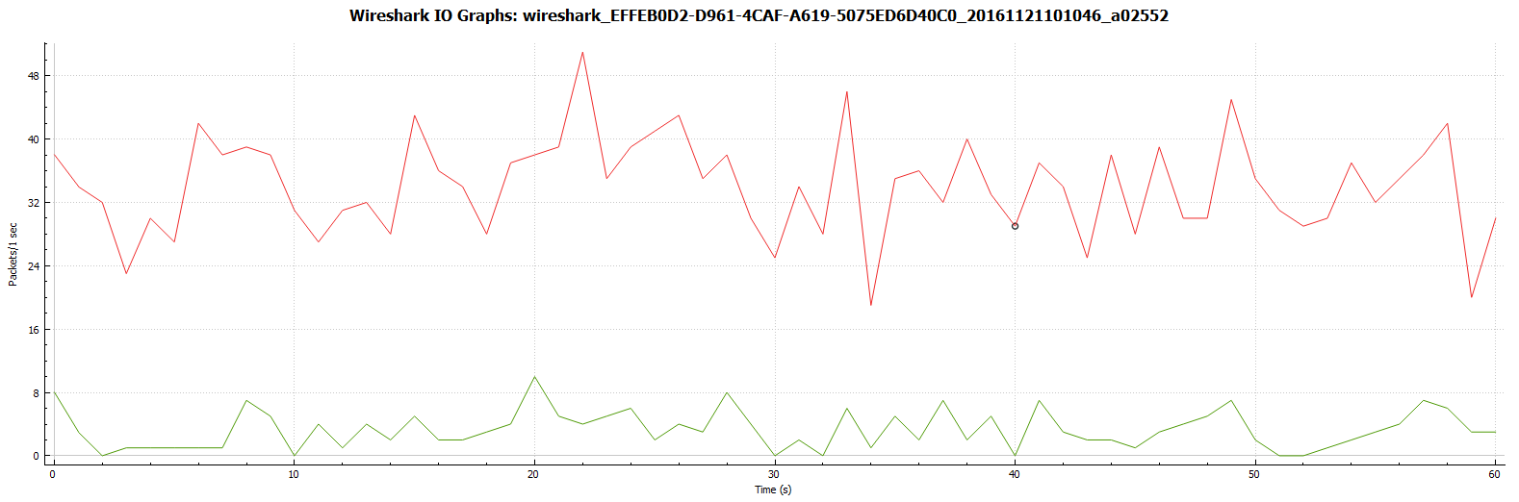

__________________________________________________________

**************** TOTAL RESULTS ******************

__________________________________________________________

Number of flows = 1

Total time = 60.826000 s

Total packets = 2079

Minimum delay = -37.055000 s

Maximum delay = -36.061000 s

Average delay = -36.581363 s

Average jitter = 0.021054 s

Delay standard deviation = 0.197728 s

Bytes received = 665884

Average bitrate = 87.578864 Kbit/s

Average packet rate = 34.179463 pkt/s

Packets dropped = 0 (0.00 %)

Average loss-burst size = 0 pkt

Error lines = 0

#### Tok 3

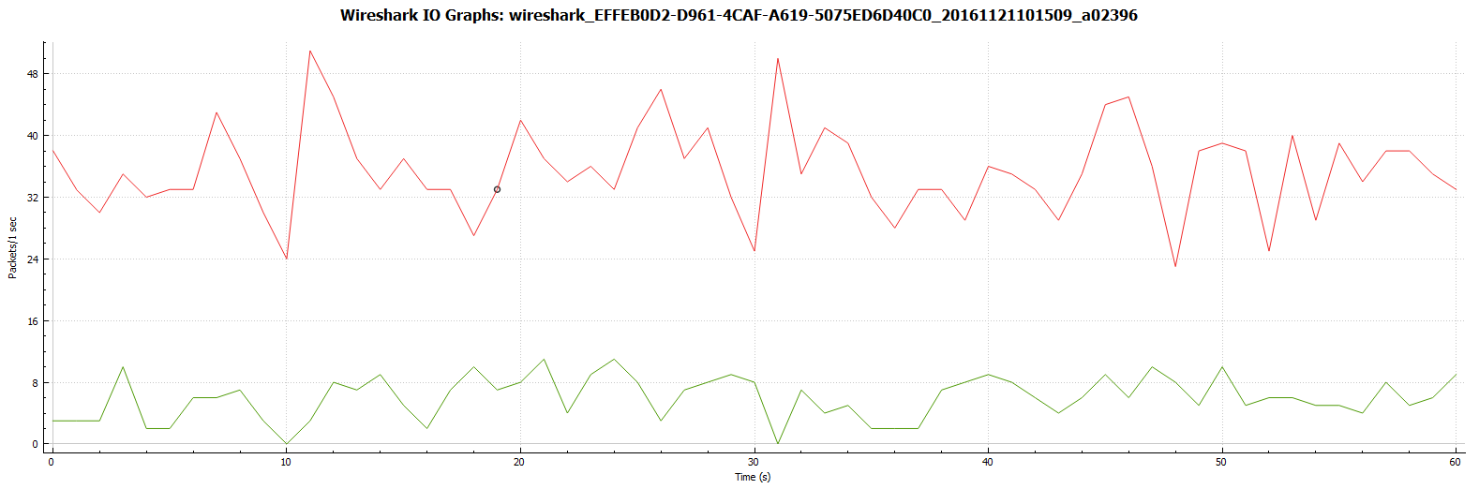

__________________________________________________________

**************** TOTAL RESULTS ******************

__________________________________________________________

Number of flows = 1

Total time = 60.910000 s

Total packets = 2135

Minimum delay = -35.636000 s

Maximum delay = -33.852000 s

Average delay = -34.875901 s

Average jitter = 0.025866 s

Delay standard deviation = 0.430451 s

Bytes received = 848882

Average bitrate = 111.493285 Kbit/s

Average packet rate = 35.051716 pkt/s

Packets dropped = 0 (0.00 %)

Average loss-burst size = 0 pkt

Error lines = 0

----------------------------------------------------------

**Preskúmajte**, akú najmenšiu hodnotu CIR v príkaze police váš smerovač povoľuje :

Po zmene CIR na 8000 (minimum) sa BC zmenilo na 1500 (1500*8 / 8000 = 1.5) teda každých 1.5s sa doplní do vedra jeden token (povolenie na prenos 1 bitu).

**2.Scenár - Single Rate Three Color Marker  (srTCM)**

**Pritekajúce** tokeny, ktoré sa nezmestia do prvého vedra, ktorého veľkosť je Bc = comform burst, sa budú ukladať do druhého vedra veľkosti Be = excess burst

* Vytvorte novú politiku POLICING2_srTCM:

1. Všetky pakety triedy ZAKAZNIK nech označkuje DSCP hodnotou 2
2. CIR ostáva ako v predošlom 84 kbps
3. Pridáme ale nastavenie pre Bc = 3000, Be = 3000
4. Pakety, pre ktoré nie je dostatok tokenov v prvom vedre, ale je dostatok tokenov v druhom vedre, nech zafarbí/označkuje DSCP hodnotou af12 (exceed-action...)
5. A pakety, pre ktoré nie je dostatok ani v prvom ani v druhom vedre, nech označkuje af13 (violate-action...)
6. Najprv deaktivujte predošlú politiku, následne aplikujte túto novú na to isté rozhranie.

policy-map POLICING2_srTCM

class ZAKAZNIK

set dscp 2

police cir 84000 bc 3000 be 3000

conform-action transmit

exceed-action set-dscp-transmit af12

violate-action set-dscp-transmit af13

červená - všetko

zelená - dscp = AF12

**čierna** - dscp = AF13

#### Tok 1

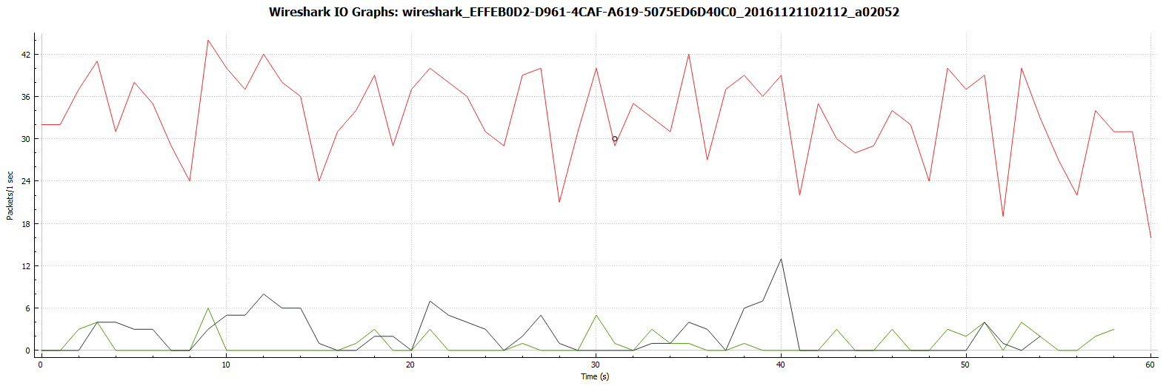

__________________________________________________________

**************** TOTAL RESULTS ******************

__________________________________________________________

Number of flows = 1

Total time = 60.491000 s

Total packets = 2026

Minimum delay = 14.988000 s

Maximum delay = 15.695000 s

Average delay = 15.310763 s

Average jitter = 0.013653 s

Delay standard deviation = 0.162754 s

Bytes received = 605838

Average bitrate = 80.122729 Kbit/s

Average packet rate = 33.492586 pkt/s

Packets dropped = 0 (0.00 %)

Average loss-burst size = 0 pkt

Error lines = 0

#### Tok2

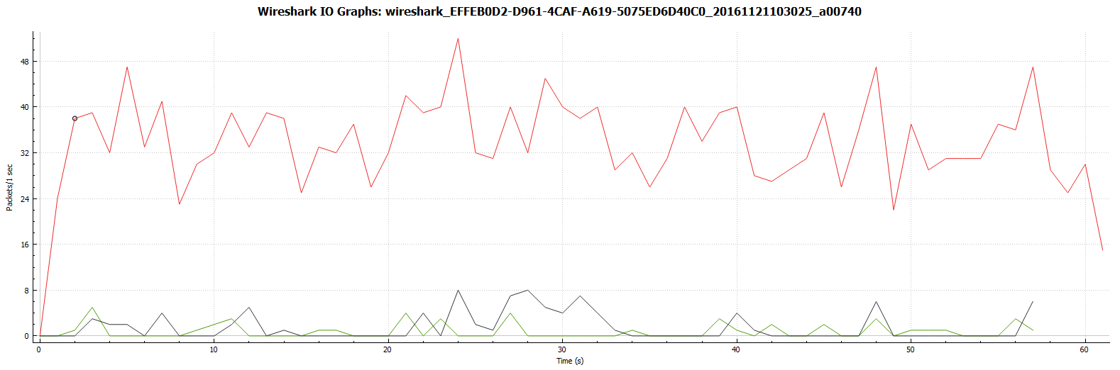

__________________________________________________________

**************** TOTAL RESULTS ******************

__________________________________________________________

Number of flows = 1

Total time = 60.151000 s

Total packets = 2078

Minimum delay = 15.078000 s

Maximum delay = 15.780000 s

Average delay = 15.279353 s

Average jitter = 0.018477 s

Delay standard deviation = 0.110203 s

Bytes received = 603487

Average bitrate = 80.262938 Kbit/s

Average packet rate = 34.546392 pkt/s

Packets dropped = 0 (0.00 %)

Average loss-burst size = 0 pkt

Error lines = 0

#### Tok3

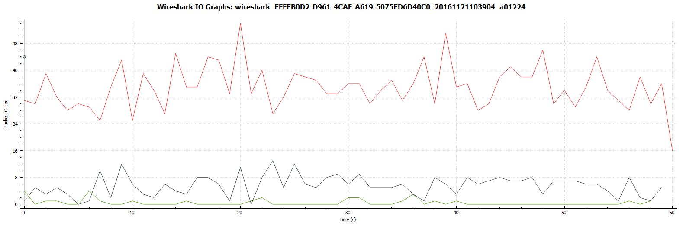

_________________________________________________________

**************** TOTAL RESULTS ******************

__________________________________________________________

Number of flows = 1

Total time = 60.304000 s

Total packets = 2096

Minimum delay = 15.419000 s

Maximum delay = 16.907000 s

Average delay = 16.038000 s

Average jitter = 0.026120 s

Delay standard deviation = 0.405311 s

Bytes received = 851236

Average bitrate = 112.925975 Kbit/s

Average packet rate = 34.757230 pkt/s

Packets dropped = 0 (0.00 %)

Average loss-burst size = 0 pkt

Error lines = 0

----------------------------------------------------------

**3.Scenár - Two Rate Three Color Marker (trTCM)**

**Teraz** chceme obmedziť tok na maximálnu ustálenú úroveň PIR=84kbps, ale pritom identifikovať jeho časť na ustálenej úrovni CIR=60kbps (**C**IR – ustálená rýchlosť na konformnej úrovni = **c**onform = rýchlosť akou sa bude plniť prvé vedro, **P**IR – ustálená rýchlosť na maximálnej povolenej úrovni = **p**eak = rýchlosť akou sa bude plniť druhé vedro). Každé vedro sa plní svojou rýchlosťou. Odoberanie tokenov pre paket, ktorý príde vo chvíli, že sa preň nájde dostatok tokenov v jednom aj druhom vedre, sa deje z jedného aj druhého vedra a paket sa prepošle.

* Vytvorte novú politiku POLICING3_trTCM:

1. Všetky pakety triedy ZAKAZNIK nech označkuje DSCP hodnotou 2 (ako v predošlom)
2. Tu ale chceme zmenu pre CIR = 60kbps a PIR = 84 kbps
3. Akcie ostanú ako v predošlom scenári:
4. Pakety, pre ktoré nie je dostatok tokenov v prvom vedre, ale je dostatok tokenov v druhom vedre, nech zafarbí/označkuje DSCP hodnotou af12 (exceed-action...)
5. A pakety, pre ktoré nie je dostatok ani v prvom ani v druhom vedre, nech označkuje af13 (violate-action...)
6. Najprv deaktivujte predošlú politiku, následne aplikujte túto novú na to isté rozhranie.

policy-map POLICING3_trTCM

class ZAKAZNIK

set dscp 2

police cir 60000 pir 84000

exceed-action set-dscp-transmit af12

violate-action set-dscp-transmit af13

červená - všetko

zelená - dscp = AF12 (exceed)

**čierna** - dscp = AF13 (violate)

#### Tok 1

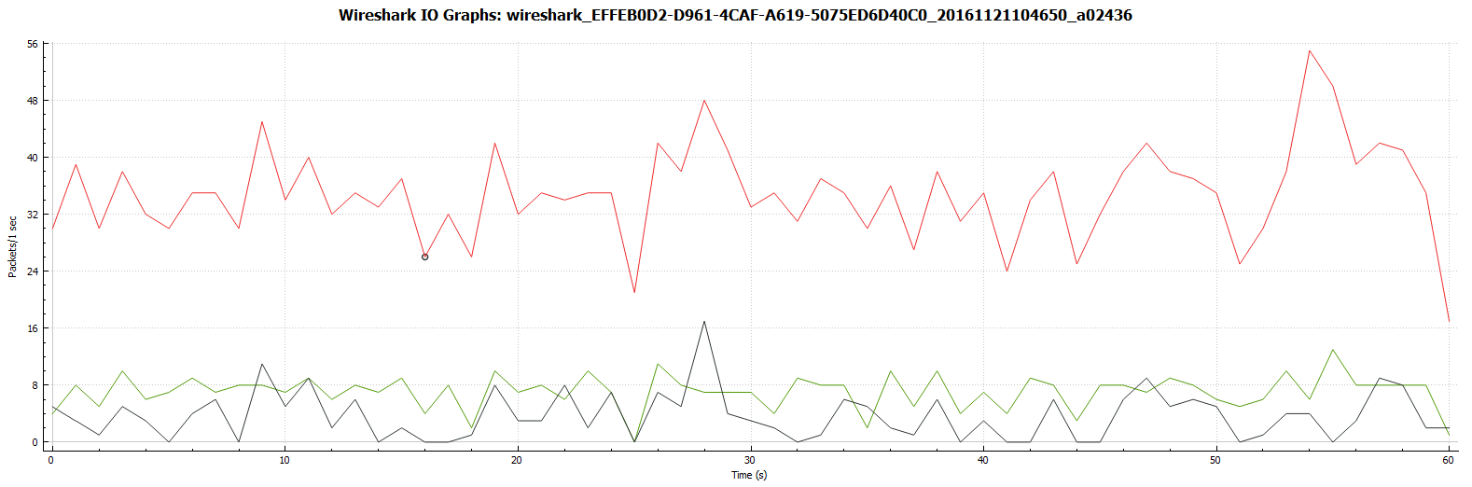

__________________________________________________________

**************** TOTAL RESULTS ******************

__________________________________________________________

Number of flows = 1

Total time = 60.665000 s

Total packets = 2081

Minimum delay = -54.500000 s

Maximum delay = -53.741000 s

Average delay = -54.128602 s

Average jitter = 0.014478 s

Delay standard deviation = 0.171691 s

Bytes received = 633931

Average bitrate = 83.597593 Kbit/s

Average packet rate = 34.303140 pkt/s

Packets dropped = 0 (0.00 %)

Average loss-burst size = 0 pkt

Error lines = 0

#### Tok 2

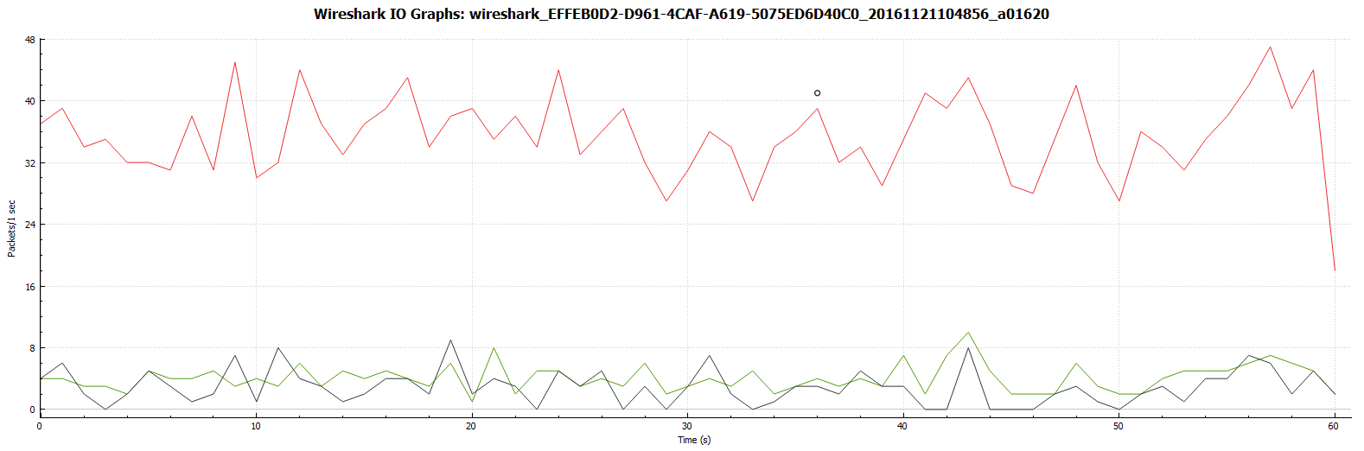

__________________________________________________________

**************** TOTAL RESULTS ******************

__________________________________________________________

Number of flows = 1

Total time = 60.350000 s

Total packets = 2162

Minimum delay = -16.042000 s

Maximum delay = -15.321000 s

Average delay = -15.707702 s

Average jitter = 0.020233 s

Delay standard deviation = 0.163767 s

Bytes received = 657504

Average bitrate = 87.158774 Kbit/s

Average packet rate = 35.824358 pkt/s

Packets dropped = 0 (0.00 %)

Average loss-burst size = 0 pkt

Error lines = 0

#### Tok 3

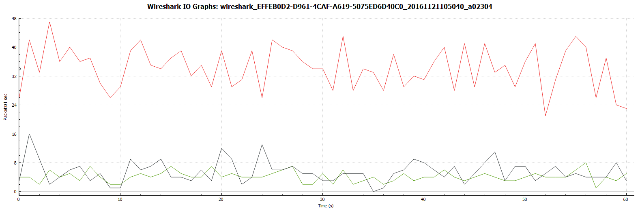

__________________________________________________________

**************** TOTAL RESULTS ******************

__________________________________________________________

Number of flows = 1

Total time = 60.495000 s

Total packets = 2090

Minimum delay = -45.592000 s

Maximum delay = -44.693000 s

Average delay = -45.247304 s

Average jitter = 0.025947 s

Delay standard deviation = 0.183992 s

Bytes received = 830603

Average bitrate = 109.840879 Kbit/s

Average packet rate = 34.548310 pkt/s

Packets dropped = 0 (0.00 %)

Average loss-burst size = 0 pkt

Error lines = 0

----------------------------------------------------------

**Vypočítajte** čas Tc z výpisu CIR a PIR zo show policy-map int f0/0, či je rovnaký interval doplnenia tokenov:

Tc(Bc) = 1875B * 8 / 60000 = 0.25s

Tc(Be) = 2625B * 8 / 84000 = 0.25s

# Shaping

**Nastavte tvarovanie prevádzky s ohľadom na priemer (shape average)**

* Podobne ako pri policingu, využite triedu ZAKAZNIK, a vytvorte policy-map SHAPING_AVERAGE na CIR = 84 kbps

policy-map SHAPING_AVERAGE

class ZAKAZNIK

police cir 84000

shape average 84000

#### Tok 1

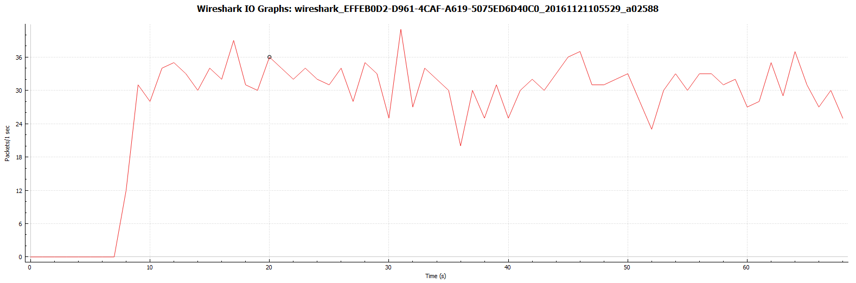

__________________________________________________________

**************** TOTAL RESULTS ******************

__________________________________________________________

Number of flows = 1

Total time = 60.129000 s

Total packets = 1885

Minimum delay = -35.869000 s

Maximum delay = -35.497000 s

Average delay = -35.703710 s

Average jitter = 0.018897 s

Delay standard deviation = 0.071041 s

Bytes received = 551378

Average bitrate = 73.359344 Kbit/s

Average packet rate = 31.349266 pkt/s

Packets dropped = 184 (8.89 %)

Average loss-burst size = 1.286713 pkt

Error lines = 0

#### Tok 2

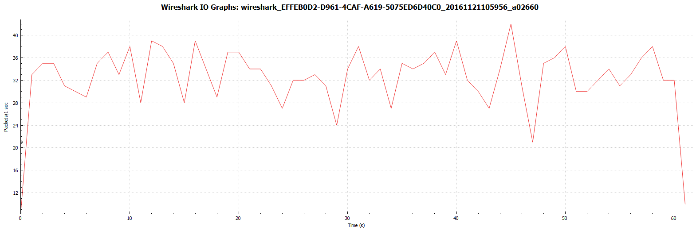

__________________________________________________________

**************** TOTAL RESULTS ******************

__________________________________________________________

Number of flows = 1

Total time = 60.588000 s

Total packets = 2008

Minimum delay = -36.387000 s

Maximum delay = -35.546000 s

Average delay = -36.025629 s

Average jitter = 0.022514 s

Delay standard deviation = 0.213738 s

Bytes received = 546594

Average bitrate = 72.171915 Kbit/s

Average packet rate = 33.141876 pkt/s

Packets dropped = 168 (7.72 %)

Average loss-burst size = 1.183099 pkt

Error lines = 0

#### Tok 3

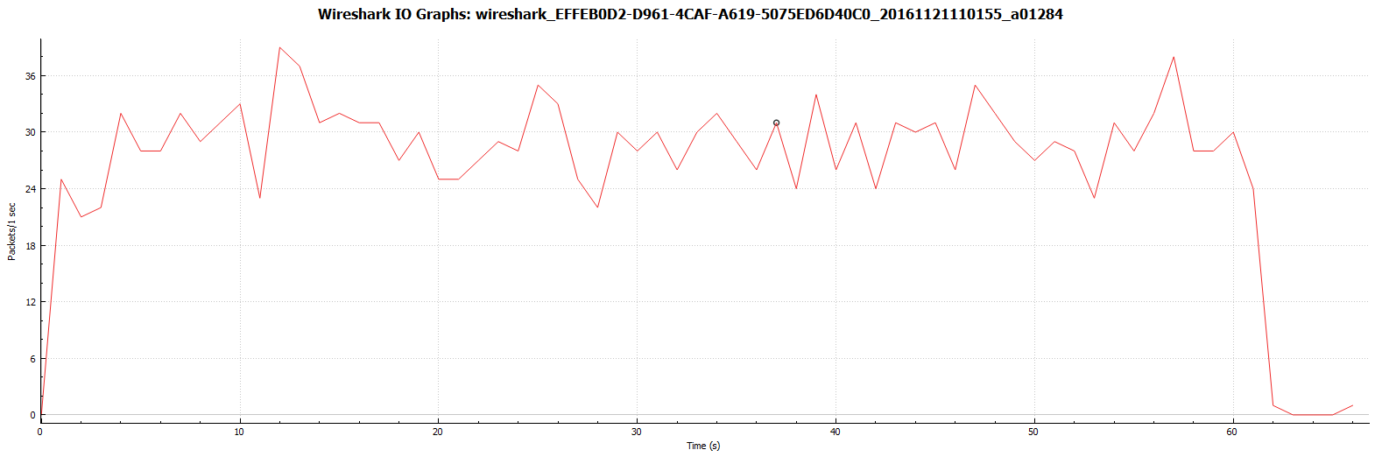

__________________________________________________________

**************** TOTAL RESULTS ******************

__________________________________________________________

Number of flows = 1

Total time = 60.589000 s

Total packets = 1771

Minimum delay = -35.788000 s

Maximum delay = -35.007000 s

Average delay = -35.366566 s

Average jitter = 0.027297 s

Delay standard deviation = 0.188618 s

Bytes received = 551165

Average bitrate = 72.774266 Kbit/s

Average packet rate = 29.229728 pkt/s

Packets dropped = 347 (16.38 %)

Average loss-burst size = 1.314394 pkt

Error lines = 0

**Nastavte tvarovanie prevádzky s ohľadom na špičku (shape peak)**

* Podobne ako pri policingu, využite triedu ZAKAZNIK, a vytvorte policy-map SHAPING_PEAK na CIR = 84 kbps

policy-map SHAPING_PEAK

class ZAKAZNIK

police cir 84000

shape peak 84000

#### Tok 1

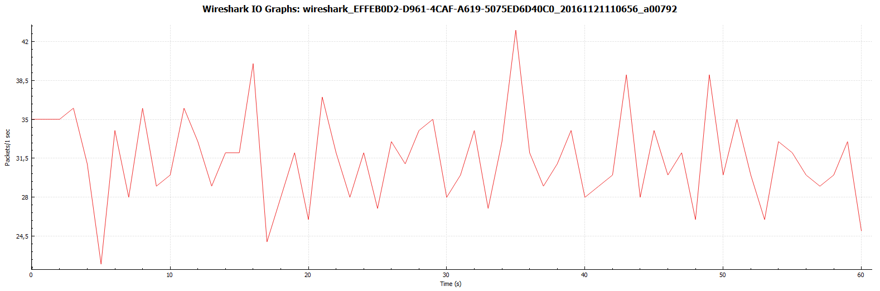

__________________________________________________________

**************** TOTAL RESULTS ******************

__________________________________________________________

Number of flows = 1

Total time = 60.587000 s

Total packets = 1921

Minimum delay = -36.534000 s

Maximum delay = -35.808000 s

Average delay = -36.273450 s

Average jitter = 0.012324 s

Delay standard deviation = 0.166496 s

Bytes received = 559749

Average bitrate = 73.910113 Kbit/s

Average packet rate = 31.706472 pkt/s

Packets dropped = 193 (9.13 %)

Average loss-burst size = 1.359155 pkt

Error lines = 0

#### Tok 2

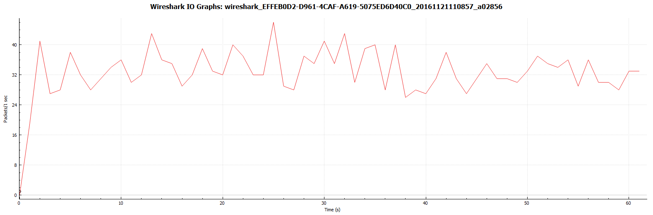

__________________________________________________________

**************** TOTAL RESULTS ******************

__________________________________________________________

Number of flows = 1

Total time = 60.309000 s

Total packets = 2027

Minimum delay = -36.927000 s

Maximum delay = -36.438000 s

Average delay = -36.749169 s

Average jitter = 0.016210 s

Delay standard deviation = 0.101796 s

Bytes received = 544281

Average bitrate = 72.198975 Kbit/s

Average packet rate = 33.610241 pkt/s

Packets dropped = 151 (6.93 %)

Average loss-burst size = 1.152672 pkt

Error lines = 0

#### Tok 3

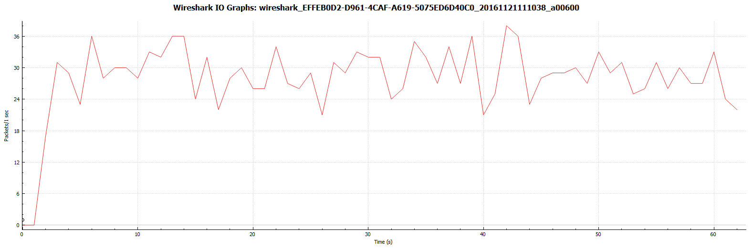

__________________________________________________________

**************** TOTAL RESULTS ******************

__________________________________________________________

Number of flows = 1

Total time = 60.545000 s

Total packets = 1759

Minimum delay = -36.574000 s

Maximum delay = -35.835000 s

Average delay = -36.210808 s

Average jitter = 0.019320 s

Delay standard deviation = 0.189189 s

Bytes received = 545639

Average bitrate = 72.096986 Kbit/s

Average packet rate = 29.052771 pkt/s

Packets dropped = 338 (16.12 %)

Average loss-burst size = 1.315175 pkt

Error lines = 0

**POLICING1_DROP (BW LIMIT 84 kb/s)**

- bez politiky

priemerne: 66kb/s

straty: 175

- s politikou

priemerne: 71kb/s

straty: 354

**POLICING1_FARBI (DSCP = 2, exceed-action DSCP = af12)**

- žiadne straty - nebola prekročená kapacita linky (86,88,111 < 128 kb/s)

**POLICING2_srTCM (DSCP = 2, CIR = 84kb/s, BC = BE = 3000,**

**exceed DSCP=af12, violate DSCP=af13)**

- žiadne straty - nebola prekročená kapacita linky (80,80,113 < 128 kb/s)

**POLICING3_trTCM (DSCP = 2, CIR = 60kb/s, PIR = 84kb/s,**

**exceed DSCP=af12, violate DSCP=af13)**

- žiadne straty - nebola prekročená kapacita linky (84,87,110 < 128 kb/s)

**SHAPING_AVERAGE (CIR 84kb/s)**

- Tok1:

priemerne: 73kb/s

straty: 184 (9%)

- Tok2:

priemerne: 72kb/s

straty: 168 (8%)

- Tok3:

priemerne: 72kb/s

straty: 347 (16%)

**SHAPING_PEAK (CIR = 84kb/s)**

- Tok1:

priemerne: 74kb/s

straty: 193 (9%)

- Tok2:

priemerne: 72kb/s

straty: 151 (7%)

- Tok3:

priemerne: 72kb/s

straty: 338 (16%)